08.03 Deferral Handling
Process Design & AMOS Configuration Document
Purpose
This Process Design document is provided to Key-Users to record their key decisions regarding the AMOS Process design and the required AMOS configuration.
It is updated throughout the Project Definition Phase and used as the baseline for the Final Acceptance prior to Go-Live
Revision
Author, Name | Date | Notes
FREL | 12/06/2024 | Initial version
DEOS | 13/12/2024 | Updated for 24.12
DEOS | 23/07/2024 | Updated flow

Table of Contents
1. Process Overview & Objectives 3
2. Regulatory References 4
3. Definitions & Glossary 4
4. Process Tasks 5
5. Process Dependencies 5
6. Process Flow 6
7. Process Design Questions 7
8. Data (Source) Mapping 8
9. Other Software Used 8
10. AMOS Configuration 8
a. Basic Data 8
b. Parameters 8
c. Workflows 9
d. Scheduled Tasks 9
e. API’s & Interfaces 10
11. Annex – Additional Info 10
a. Maintenance Release to Service 10

Process Overview & Objectives

Process General Description:
This process is intended to handle the items that cannot be performed during maintenance activities. This process is therefore generally performed by the Maintenance staff of an MRO or an airline. Only the event de-assignment part is usually executed by the Fleet Planning staff or MCC depending on the configuration.
The trigger for this process is the fact that a maintenance action cannot be performed, and the output of this process if the fact that this event has been handled in the system. It is important to distinguish two types of actions in the process:
- “Not performed” – Meaning the Maintenance staff has simply not performed the task due to any reason, but without the possibility of interacting with the event forecast.
- “Defer” or “Transfer” – Meaning the Maintenance staff has not performed the task due to any reason but has the possibility of changing (or requesting a change) in the event forecast.
It is important to note that both actions are licenced in the system which allows the AMOS Competence Centre to define which user can perform each action.
The main benefits identified for the organisation when fully adopting this process are the following:
- Event status precision: By correctly tracking the status of an event it is possible to precisely determine the airworthiness status of the aircraft it relates to.
- Enhanced control on maintenance execution and seamless records generation: The status of each event will automatically be reflected in the aircraft maintenance records including the CRS.
- Enhanced communication between departments: The status of the “non-performance” of the events is set in the database which automatically updates the forecast information, and allows for better event planning. This also removes the requirement of labour intensive information spreading.

Main Process Objective (Outputs & Outcomes):
It is important to stress that a release to service, whether it is single or multiple, does not necessarily mean that the aircraft is airworthy and ready for flight. A release to service is just a release after the performance of maintenance and its issuance is the responsibility of the maintenance organisation. However, the responsibility for defining the airworthiness status of the aircraft is the responsibility of the CAMO/operator.
For more details related to the release to service please refer to the chapter 11.a
It is important to use the correct terminology and associated action when a maintenance task is not done. For instance a standalone MRO does not require to defer or transfer any item. As they are contracted by an airline to perform a job they can either do it or not. As they do not necessarily have the aircraft airworthiness data in their system, they cannot know if they can defer or transfer, and mainly, they do not need to track the next dues of the aircraft.
The objective of this process is to efficiently handle events that have not been performed in a was that suits the Airline and/or MRO.

Regulatory References

The following regulatory references in link with this process were identified:
- EASA Part-145 – 145.A.50 Certification of maintenance
- EASA NPA 2014-27.
- EASA Part-M – GM M.A.301 Continuing airworthiness tasks.
- EASA Part-M – GM M.A.305(a) Aircraft continuing airworthiness record system.
- EASA Part-CAMO – CAMO.A.315 Continuing airworthiness management

Definitions & Glossary

Key-Words | Explanation
Workorder (W/O) | The workorder is the object were all maintenance activities are recorded. In connection with unscheduled maintenance all defect / malfunction are recorded in a workorder. The workorder can be created in different ways.
Workpackage | The workpackage is the container for various maintenance events. Unscheduled and scheduled maintenance event can be included. Workpackages are handed over to the MRO to clearly define the scope of work.
Work Template | Work instructions which are saved as template. Main use case is the usage for scheduled maintenance events but there are also possibilities and use cases to use pre-defined templates for unscheduled maintenance.
Pickslip | Material requisition form which is send to logistic staff to inform about material request
Labelbooking | Booking of a component change
AMOSmobile/EXEC | Web browser based, touched optimised front end which is used by mechanic for work execution

Process Tasks

Main Process Task / Actions / Activities:
The following actions are performed in this Business Process:
- Indicate item as not performed: When an item is not performed by a standalone MRO or removed from the scope of work in an Airline/MRO configuration. Once triggered or informed, they can mark the item as not performed. The event can then be de-assigned from the work package by the CAMO organisation.
- Defer TC/CR: When a TC/CR item inside a work package cannot be performed, this item requires to be deferred based on Minimum Equipment List (MEL), Configuration Deviation List (CDL) or using other approved data/classified as non-airworthiness item (DD). The maintenance staff can defer the item indicating next dues and a reason for deferral. The item forecast will be updated with this data.
- Transfer WO: Using the Transfer for workorders is normally used when a defect cannot be fixed immediately and should be deferred based on Minimum Equipment List (MEL), Configuration Deviation List (CDL) or using other approved data/classified as non-airworthiness item (DD). A workorder which is transferred, is still open and have a due date (directly set or calculated based on expiration). As the Workorder is still open this will have an impact on the aircraft status and used to feed other processes and application - especially to provide Flight Operation and MCC important information which are required for aircraft operation.
- Undo Deferral/Not Performed: When the CAMO rejects this decision from the Part-145, there is the possibility to undo this deferral or not performed action to put the event back in the pending list. Note: this is not applicable to events not in a workpackage.
- De-assign event from WP: This action is the only step performed by the CAMO or MCC as they are responsible for the content of the work package scope. When the defer/transfer is approved, the event can be de-assigned from the work package and re-planned.
Note: this is not applicable to events not in a workpackage.

Process Dependencies

The following process dependencies were identified:
- 04.04 – Approval Control: This process can trigger approval loops to add additional layers of control.
- 08.02 – Performing Maintenance: This process is directly linked to performing maintenance as it covers all the cases where maintenance is requested but cannot be performed. The Deferral handling occurs after the Performing Maintenance.
- 08.05 – Release to Service: This process is linked to the release to service as it usually highly influences the release to service records generation.

Process Flow

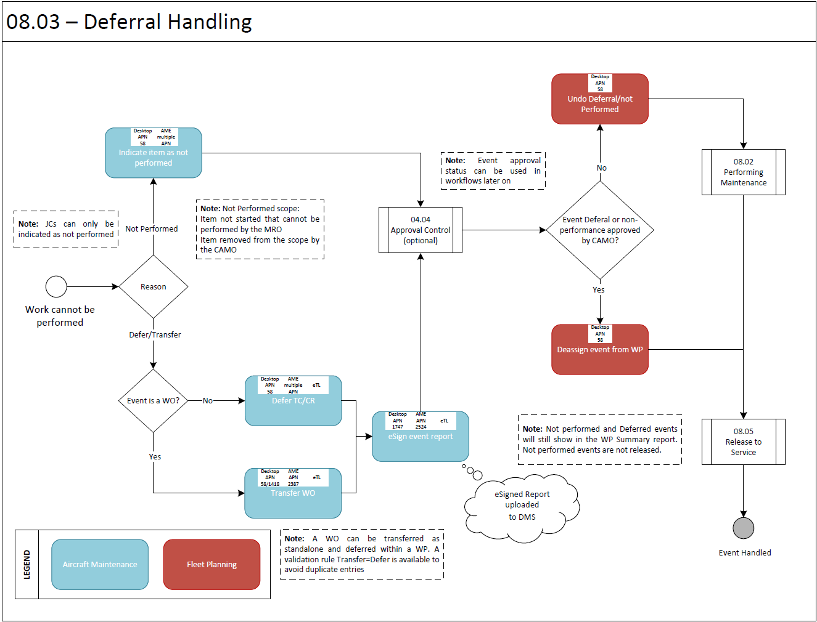

Process Design Questions

# | Question | Answer
1 | Which kind of Technical Logbook is used - hardcopy or electronic?
2 | Who will issue a Pickslip request?
3 | Who is responsible to managing, monitoring, and planning short running defers (MEL, CLD, etc.) in daily operations?
4 | Is there a centralised Maintenance Control Center (MCC)?
5 | Does the MCC belongs to CAMO or production department / business area?
6 | How will you handle defect on an outstation and coordinate required the actions?
7 | Does a time delay exist until data is entered into the System? How long?
8 | Who is responsible for data entry?
9 | Will pickslips always be issued with workorder reference or also without?
10 | Who need information about aircraft status and how to inform them?

Data (Source) Mapping

Data Sources | Description | Volume / Manual / Automatic / Static / Dynamic
-Nil-

Other Software Used

Other Softwares | Used by: | Description
-Nil-

AMOS Configuration

Basic Data

Basic Data Table | Notes
Limitation Type | Define available limitations which can be caused by defect transfer
Priority | Define (planning) priority of workorder which is shown in Maintenance Forecast
Maintenance Event Extension Codes | Define reason of transfer of workorder
Basic Tables/ Maintenance Event Extension Codes | E: Extension  The extensions are used in Maintenance Forecast for the extension of a maintenance item e.g., on Extend Event, Transfer or Defer.  N: Not Performed  This type can be used to mark an event of a work package as not performed.
PDF Overlay/ Reason Why N/A or Not Performed | When a mechanic set a stamp box as N/A, Not Performed in PDF Overlay he could need to set the reason why.  Here are stored the different values for the reason why.

Parameters

Parameter Code | Parameter Name | Notes
1363 | Free MEL Edit | In case MEL book is available in AMOS it is recommended to allow only known MEL / CDL items for transfer
1741 | Worpackage Not Performed, Defer, Release Configuration | The String value controls the automatic de-assignment of deferred and not performed events.
1806 | Auto de-assign on deferral / not perform based on priority | You can specify all priorities for events (defined in basic data) separated by a semicolon that should not be automatically de-assigned.
1897 | AMOSeTL: Allow pilots to defer and/or close defects | This parameter defines whether or not pilots are allowed to defer and / or close defects in AMOSeTL.
1919 | AMOSeTL: Allow Pilot and Maintenance to defer cabin items | This parameter defines whether Pilots and Maintenance users are allowed to defer new cabin items.

Workflows

Workflow Number | Workflow Name | Notes
100 | After a workorder is saved | This workflow is started after a W/O is saved in Desktop
406 | After a workorder is saved | This workflow is started after a W/O is saved in AME
411 | After a W/P event is closed, deferred, or marked as not performed | This workflow is started after a W/P event is closed, deferred, or marked as not performed.
439 | Before a W/P event is closed, deferred, or marked as not performed | This workflow is started before a W/P event is closed, deferred, or marked as not performed.
512 | Event Closed / Not Performed (Post-Save) | This workflow is started after a W/P event is closed, deferred, or marked as not performed.
528 | Reopen, Undo Deferred or Not Performed events (post-Save) | This workflow is started after a W/P event has been reopened or moved to pending from deferred or not performed t using Undo action
529 | Reopen, Undo Not Performed events (post-Save) | This workflow is started after a W/P event has been reopened or moved to pending from deferred or not performed t using Undo action

Scheduled Tasks

Scheduled Task Reference | Frequency | Notes
N/A

API’s & Interfaces

Reference | Direction | Trigger | Frequency
EXPORT AMOS ETL WO DEFERRAL OR CLOSURE | Export | Export AMOS ETL WO Deferral or closure data | As required
TRANSFER MRO RESULT | Export | Use to export from MRO system and import in Operator system a performed workpackages. Must have used service TRANSFER MRO WORKPACKAGE to initialize the workpackages in the MRO system. | As required

Annex – Additional Info

Maintenance Release to Service
The following aspects are to be considered for the release to service:
- The owner/operator (or contracted CAMO) is responsible for all activities aimed to determine the airworthiness status of the aircraft and to appropriately plan and coordinate maintenance, and
- The contracted maintenance organisation or, when permitted by the rule, the independent certifying staff, are responsible for adequately performing and certifying the maintenance ordered by the owner/operator/CAMO.
- The operator (CAMO) cannot issue Certificates of Release to Service (CRS) following maintenance. The CRS must be issued always by certifying staff of the Part-145 organisation.
- When maintenance is performed and released by the Part-145 organisation, the operator must have procedures to verify that all the maintenance ordered to that organisation has been released to service by the approved Part-145 organisation. However, in order to perform this verification, the operator (CAMO) is not required to use certifying staff.
- Since the CRS only certifies that the maintenance ordered by the operator (CAMO) has been performed and released in accordance with Part-145, it does not guarantee that all the continuing airworthiness requirements are met (there may be some missing maintenance that has not been ordered by the operator). This is the responsibility of the operator (CAMO).
- Consequently, the operator (CAMO) must have procedures to ensure that a flight does not take place unless all the continuing airworthiness requirements are met. This could be met, for example, by a procedure where the operator (CAMO) receives a communication from the maintenance organisation and the operator (CAMO) notifies to the commander that there is no other maintenance due. However, other procedures are possible, for example, delegating to the Part-145 the notification to the commander.
- The CRS issued by the Part-145 organisation has to go always on board the aircraft as part of the Technical Log System, together with all the information related to rectification of defects, deferral of maintenance actions, etc. This information has to be always available to the commander (refer to M.A.306 and AMC M.A.306(a)), who is the ultimate responsible for accepting the aircraft before a flight takes place.
- The Technical Log System must also contain a maintenance statement issued by the operator (CAMO) providing the status of which scheduled and out of phase maintenance is next due. However, this maintenance statement does not need to be on board if the operator (CAMO) has alternate procedures acceptable for the competent authority in order to control the next maintenance due [refer to M.A.306 and AMC M.A.306(a)].
- This maintenance statement, if placed on board the aircraft, does not supersede the obligation to have the Part-145 CRS on board and available to the commander.

